Two men critically wounded in Mattapan, South End shootings

**By Travis Andersen** Globe Correspondent and Globe Staff, April 21, 2014, 11:18 p.m.

Two men were critically injured in separate shootings Monday night in Boston, one in Mattapan and one in the South End, according to officials.

A 25-year-old man was shot multiple times on a dead-end street off of River Street in Mattapan around 7:30 p.m., authorities said.

The unidentified victim was taken to Boston Medical Center and was in critical condition, said EMS spokesman John Gill.

“He was actually talking when he left,” Deputy Superintendent John Brown of the Boston police said. “God willing, he’ll be all right.”

Shortly after 8:30 p.m., crime scene investigators arrived at the scene on Riverbank Place. They set up lights and began scanning the area around a white, two-story house halfway down the street.

Advertisement

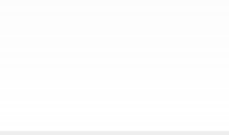

|  |  |  |
| --- | --- | --- |
|  |  | Memory Ice Tassel Graduation Ann… Graduation Ann…  Class Dog Tag … Thank You Notes Graduation Ann…  Class Envelope … Graduate Portfolio Graduation Ann…    Diploma Plaque Memory Tassel Classic Hoodie |
| Cap, Gown, & Tassel  Diploma Signatu… Graduation Ann… |

Police recovered some ballistics evidence from the scene, Brown said.

Around 9:10 p.m., an unidentified man in his 30s was shot in a bustling commercial district in the South End, officials said.

**Get Today's Headlines in your inbox** Enter Email

[example@email.com](mailto:example@email.com)

**Sign Up**

The day's top stories delivered every morning.

Boston Police said the shooting occurred near the corner of Tremont and Aguadilla streets. A second crime scene was visible one block over at Tremont and West Brookline streets. Several evidence markers were placed on West Brookline, which was also taped off.

Gill said the victim was 37 years old and was in critical but stable condition at Boston Medical Center.

Police had the shooting scene, located near popular restaurants including Upper Crust and Tremont 647, roped off with tape at about 10 p.m. as they searched for evidence.

Matt Coolidge, 32, of South Boston, said he was standing near the two intersections on Tremont when he heard several shots ring out.

Coolidge said he saw a man and a woman dive for cover behind a vehicle but saw no cars or suspects fleeing.

A neighborhood resident who would only give his first name, John, said he also heard a barrage of gunfire.

Advertisement

“Just a nice quiet day, and then all you heard was” shots, John said.

Also Monday night, at about 7:30 p.m., a youth in his late teens walked into Boston Children’s Hospital with a gunshot wound, Boston Police spokesman James Kenneally said.

Kenneally said the teen had been shot in the ankle, but no other information was available. The three shootings did not appear to be related, he said.

Globe correspondent Jennifer Smith contributed to this report. Todd Feathers can be reached at [todd.feathers@ globe.com. Follow him on Twitter @ToddFeathers. Travis Andersen can be](mailto:todd.feathers@globe.com.FollowhimonTwitter@ToddFeathers.TravisAndersencanbe) [reached at travis.andersen@globe.com. Follow him on Twitter @TAGlobe.](mailto:reachedattravis.andersen@globe.com.FollowhimonTwitter@TAGlobe)

**BOSTON GLOBE VIDEO**

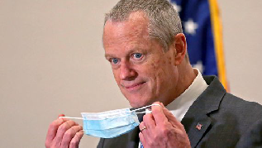

2:23

Baker announces ‘VaxMillions’ lottery program SHARE

Governor Charlie Baker announced residents who are fully vaccinated against COVID-19 will have the chance to win $1 million in a special Lottery sweepstakes. (Photo by Matt Stone/Boston Herald via AP)

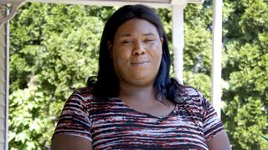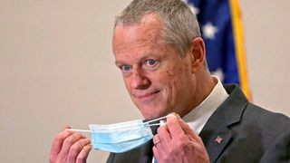

**Baker announces ‘VaxMillions’ lottery program**

**NOW PLAYING**

**Moose spotted on Route 3 in Chelmsford**

**What Black liberation means to me: Athena Vaughn**

**SEE MORE VIDEOS**

**MOST POPULAR ON BOSTONGLOBE.COM**

1. Some lawmakers want to ban critical race theory in schools. So, what is it?
2. Life sciences is poised to be Boston’s dominant industry. Has the area become the Silicon Valley of biotech?
3. ‘Matty in the Morning’ co-host Rebekah ‘Bex’ Maroun is leaving Kiss 108 following on-air incident
4. The state’s second-biggest health insurer has a buzzy new name
5. How Massachusetts communities are celebrating the state’s first official Juneteenth
6. ‘My Name Is Bulger’: A tale of two brothers
7. I got the Johnson & Johnson vaccine. The pause makes me believe in it more.
8. Is there something wrong with the air in South Portland, Maine?
9. The downside of ditching masks: the return of colds, flu
10. A treasure map for an American tyrant



**VIEWS FROM OUR COLUMNISTS**

**YVONNE ABRAHAM**

Energy efficiency is a low-hanging fruit to combat climate change. So why can’t everyone get access to it?

**KEVIN CULLEN**

Bill Bratton on American policing and the challenge facing the Boston Police Department

**THOMAS FARRAGHER**

A salute across the ages to an old squad leader

**SHIRLEY LEUNG**

A working mother’s manifesto: Pandemic provides a once-in-a-generation chance to course correct how we work

**JENEÉ OSTERHELDT**

The pride I carry with me: Karim

**ADRIAN WALKER**

‘The best Boston movie no one’s ever seen’: ‘Blue Hill Avenue’ at 20

**MORE ON GLOBE.COM**

**SPONSORED BY: HARVARD PILGRIM HEALTH CARE**

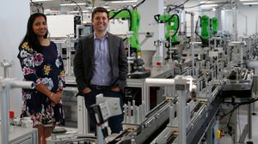

**Parents say they learned these 4 lessons from life in the age of COVID-19**

How the pandemic shifted New England parents’ perspectives.

**THE GREAT DIVIDE**

**Some lawmakers want to ban critical race theory in schools. So, what is it?**

As national debate over race-related curriculums rages on, here is a lesson on the subject and the controversy surrounding it.

**INNOVATION ECONOMY**

**Life sciences is poised to be Boston’s dominant industry. Has the area become the Silicon Valley of biotech?**

Since December, you can find six major indications that Boston is the undisputed center of the life sciences industry, a place where ideas and products that change — and save — people’s lives around the world originate.

**‘Matty in the Morning’ co- host Rebekah ‘Bex’ Maroun is leaving Kiss 108 following on-air incident**

Co-host/executive producer Rebekah “Bex” Maroun announced on Wednesday that she would be leaving Kiss 108 to move home to her native Philadelphia. Her departure caps a turbulent month for “Matty in the Morning,” the drive-time show helmed by long-time host Matt Siegel.

**The state’s second-biggest health insurer has a buzzy new name**

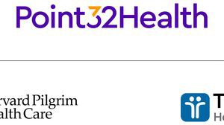

Tufts Health Plan and Harvard Pilgrim Health Care merged in January but didn't name the new company they created until Wednesday: Point32Health.

**‘My Name Is Bulger’: A tale of two brothers**

The Discovery+ film offers an unusually intimate view of Whitey and Bill Bulger.

**GLOBE MAGAZINE**

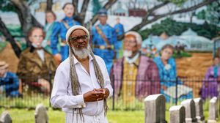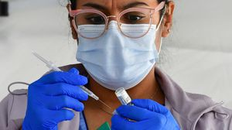

**Is there something wrong with the air in South Portland, Maine?**

Residents have lived near more than 100 massive petroleum storage tanks for decades, never really knowing if they’re breathing in dangerous chemicals. Now they’re fighting to find out.

**How Massachusetts communities are celebrating the state’s first official Juneteenth**

For more than a century, Juneteenth was a Texan holiday, then a Southern holiday, commemorating the anniversary of June 19, 1865, when General Gordon Granger of the Union Army told formerly enslaved people in Galveston they were free. Now it will be celebrated for the first time across the Commonwealth as an official state holiday.

**OPINION**

**I got the Johnson & Johnson vaccine. The pause makes me believe in it more.**

The worst thing that could happen now is for the recommendation by the FDA and CDC to pause the vaccine’s administration to spur a new wave of vaccine hesitancy.

**The case for prosecuting Donald Trump**

Saving American democracy for the long run requires a clear condemnation of the Trump presidency. That means making clear that no one is above the law.

**MOST READ IN THIS SECTION**

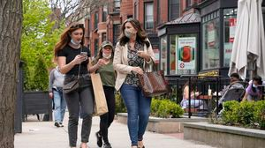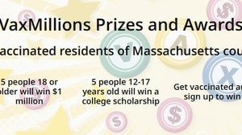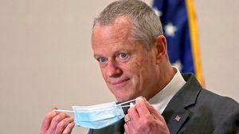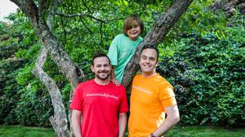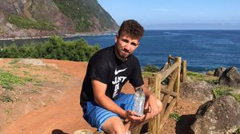

**THE GREAT DIVIDE**

**Some lawmakers want to ban critical race theory in schools. So, what is it?**

**GLOBE MAGAZINE**

**Is there something wrong with the air in South Portland, Maine?**

**How Massachusetts communities are celebrating the state’s first official Juneteenth**

**The downside of ditching masks: the return of colds, flu**

**Baker announces ‘VaxMillions’ lottery program, offering $1 million cash prizes to boost vaccination rates**

**Baker signs bill extending pandemic-era policies, including to-go cocktails, expanded outdoor dining**

**A Milton gay couple was harassed anonymously for years. Then a piece of handwriting unraveled the mystery**

**RI NEWS**

**Message in a bottle, tossed into the sea in Rhode Island, found in Azores**

**FOLLOW US**

**SUBSCRIBE NOW MY ACCOUNT CONTACT MORE**

Digital Access / Home Delivery / Gift Subscriptions

Log In /

Manage My Account / Customer Service

Help & FAQs / Globe Newsroom / Advertise

Newsletters / View The EPaper /

Order Back Issues / News In Education / Search The Archives / Privacy Policy / Terms Of Service / Terms Of Purchase / Work At Boston Globe Media /

Do Not Sell My Personal Information

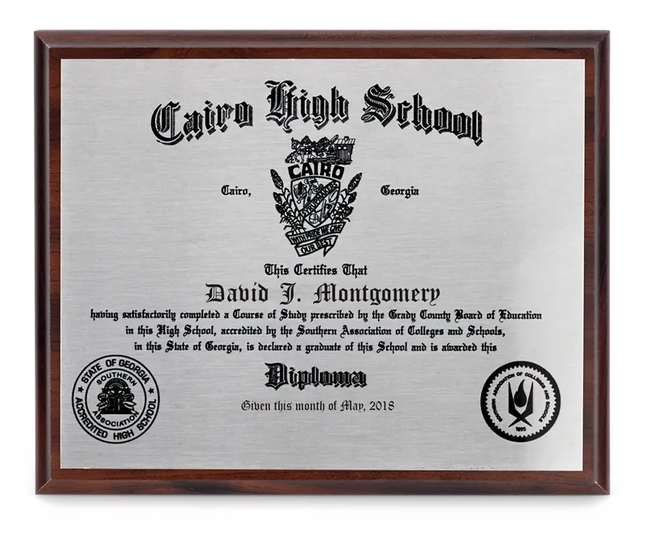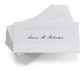

Cap, Gown, & … Thank You Notes Diploma Signat… Class Dog Tag …

Graduation An… Diploma Plaque Graduation An… Graduation An…

Memory Ice Tassel

Graduation An… Memory Tassel Class Envelope… Graduation An…

**METRO SPORTS BUSINESS & TECH OPINION**

WELCOME, JOHN

**TODAY'S PAPER**

**Summer Fitness Challenge Starts Monday**

Sign up now

©2021 Boston Globe Media Partners, LLC